HERO SECTION
Theme
The Terrarium – A Curated Corporate Ecosystem
Core Message
Every resilient business is built within a carefully designed ecosystem of governance, compliance, structure, and strategic guidance.
Why it works
- Premium and minimal
- Glass symbolizes transparency
- The ecosystem symbolizes business growth
Use only the corner of a terrarium with soft reflections.
Large empty space for typography. Very similar to AZB.
Font, Body
Background Colour
Primary Background
Warm Ivory, Dark Green combination
Avoid pure white.
Accent Colours
Element | Colour
Buttons | Antique Gold (#B18A43)
Button Hover | Deep Bronze (#8D6A2F)
Divider Lines | Soft Stone (#D9D4CC)
Glass Highlights | White with 20–30% opacity
Icons | Antique Gold (#B18A43)

Design Language
- Image: Soft, editorial lighting with no bright greens.
- Style: Architectural photography rather than nature photography.
- Spacing: Plenty of negative space, like AZB's homepage.
- Animation (optional): A subtle light reflection moving across the glass every 8–10 seconds, avoiding noticeable plant movement.
This establishes the Terrarium as a refined metaphor for a well-designed corporate ecosystem, rather than as a literal decorative element. It immediately differentiates Regis & Savoy Corporate Services while maintaining the understated sophistication seen on the AZB website.
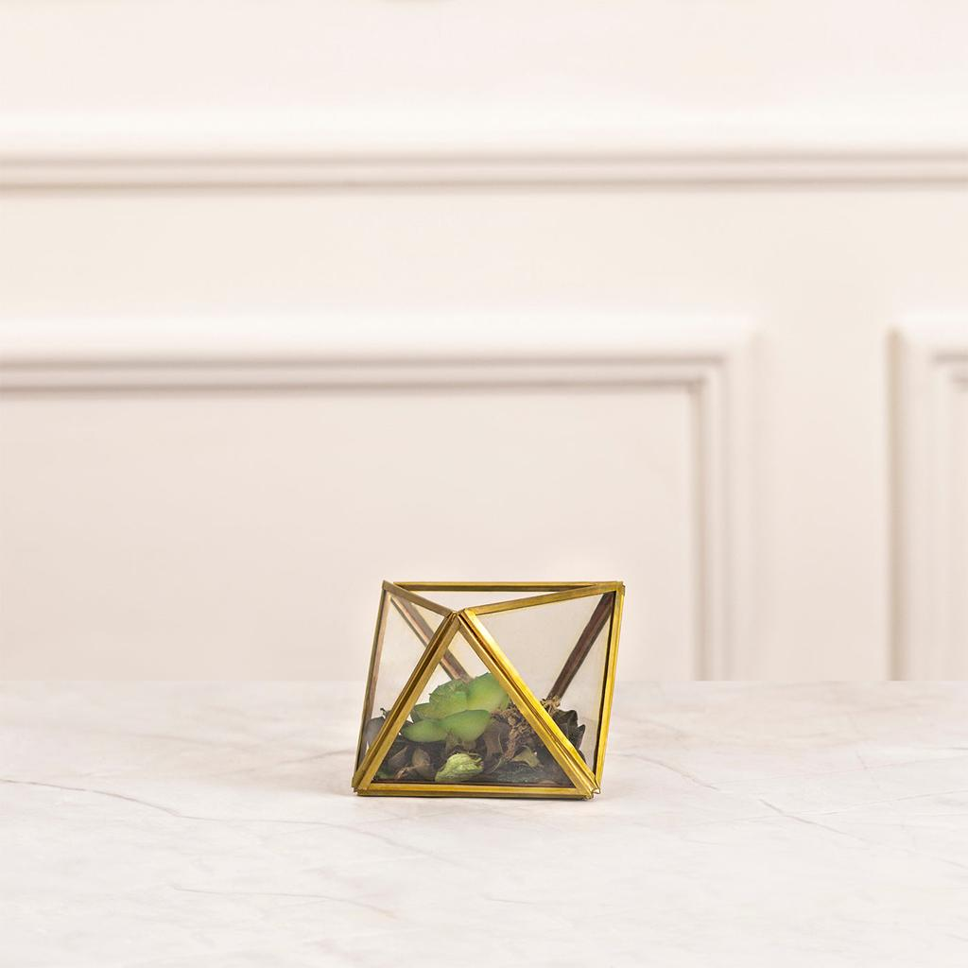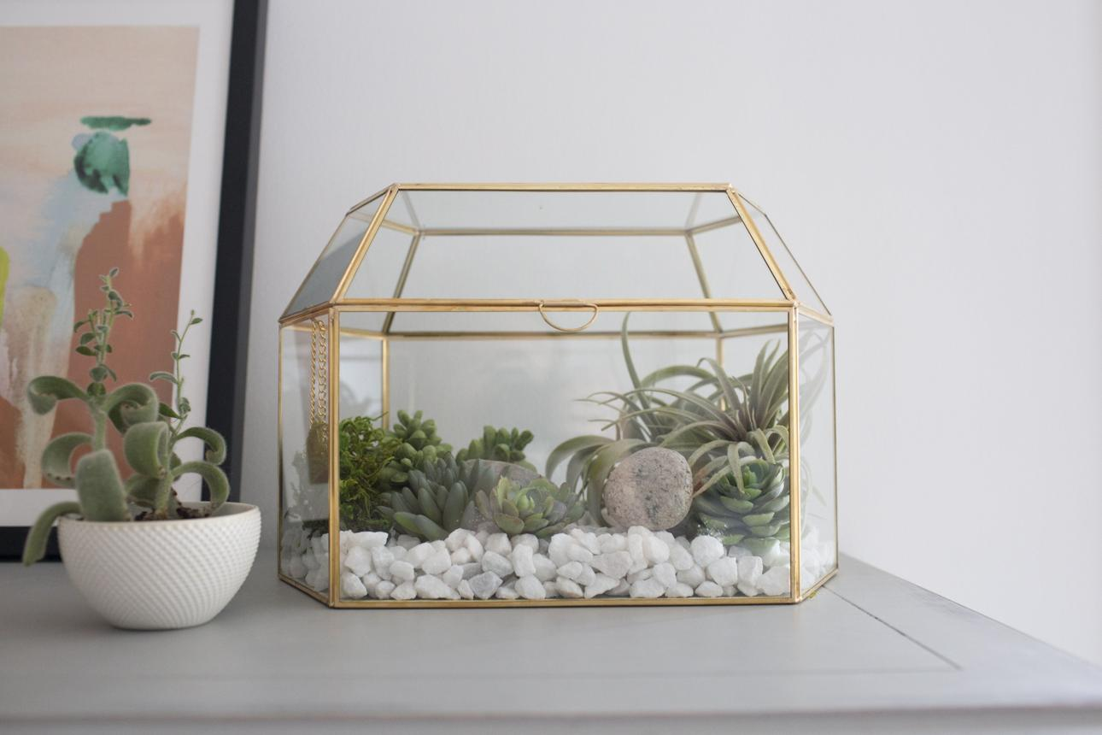
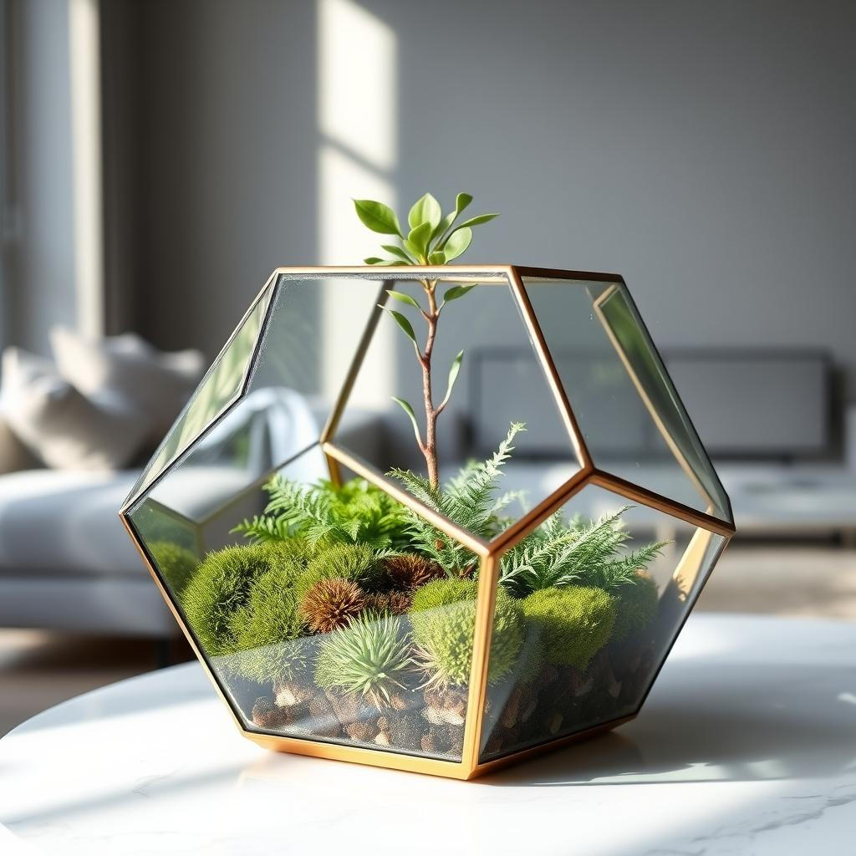
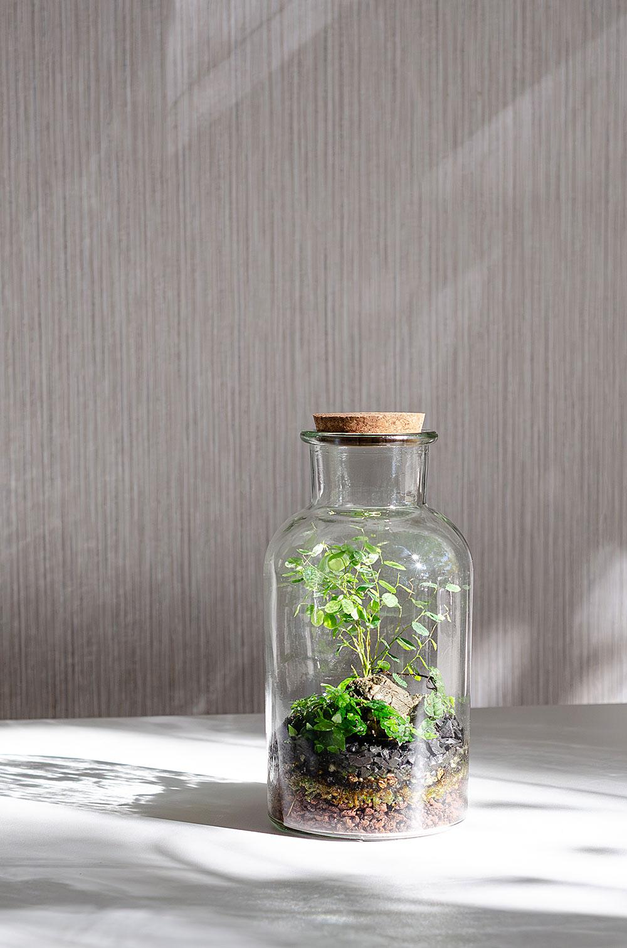

These images communicate:
- Balance
- Precision
- Longevity
- Stability
- Curation
- Sustainable growth
All without relying on clichéd corporate visuals.

Design Direction
Background
Warm Ivory – #F7F4EE
Suggested Icon Style
Avoid standard corporate icons.
Instead, use premium monoline botanical-architectural icons such as:
Principle | Icon Concept
Governance | Root network
Compliance | Glass enclosure
Risk Management | Balanced water droplet
Business Structuring | Layered stone foundation
Due Diligence | Botanical magnifying glass
Investment Readiness | New emerging shoot
Technology | Leaf with subtle circuit pattern
Corporate Growth | Structured branching form
All icons should be:
- Thin line (1.5–2 px)
- Single colour (Antique Gold)
- Rounded line ends
- Minimal and architectural

Overall Feel
Imagine this section as if it belongs in:
- An architectural journal
- A luxury design magazine
- A high-end strategy consulting firm's annual report
It should feel quiet, confident, and timeless.

For a premium corporate website, I would avoid decorative or hobby-style terrariums. Instead, look for architectural, minimalist glass terrariums that feel like design objects rather than garden accessories.
Architectural Geometric Terrariums

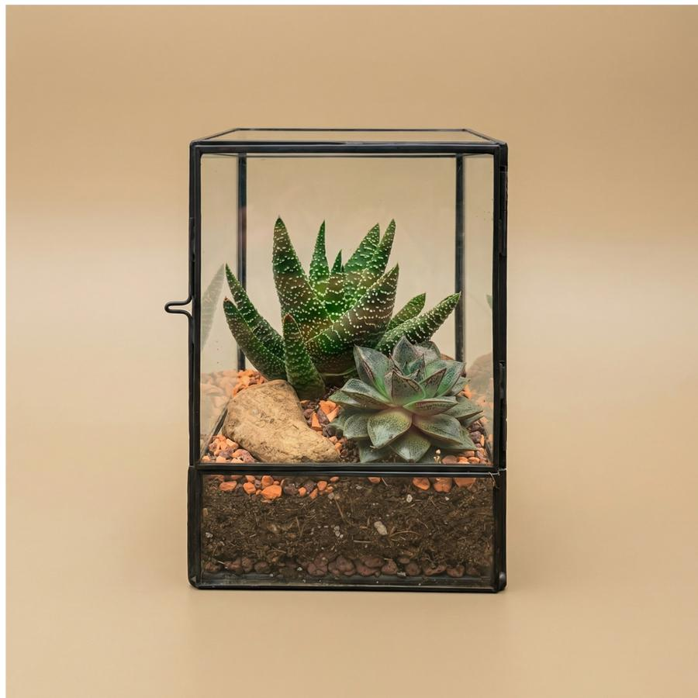

Minimal Scandinavian Terrariums

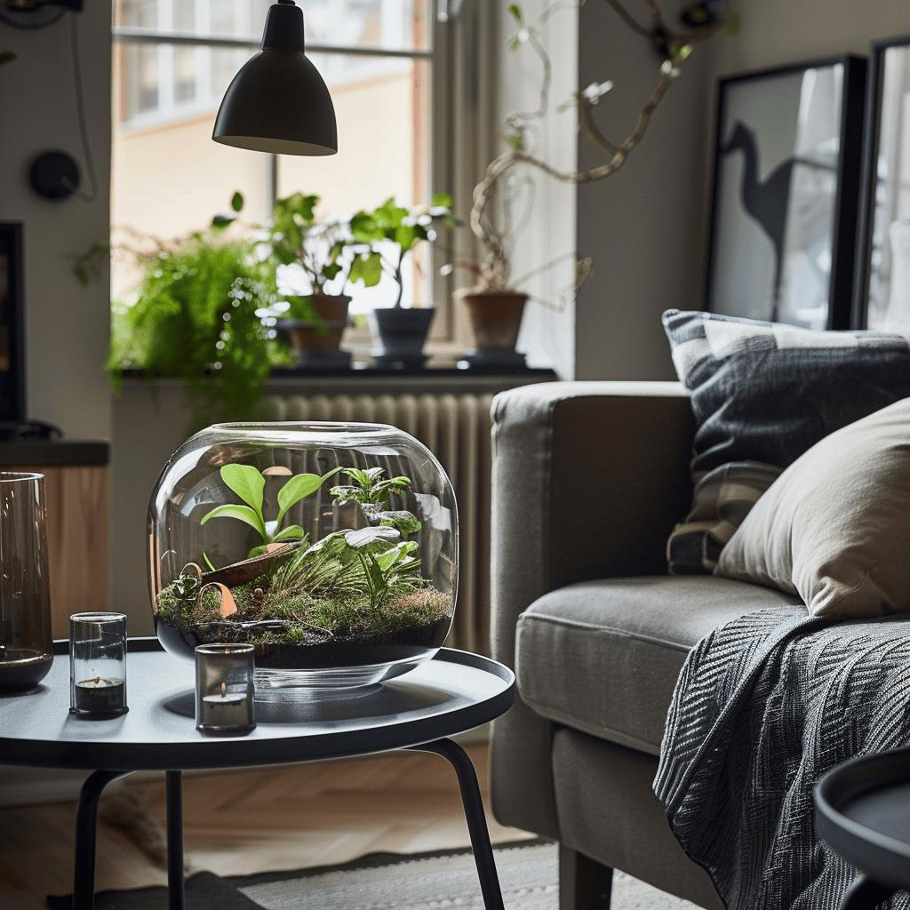
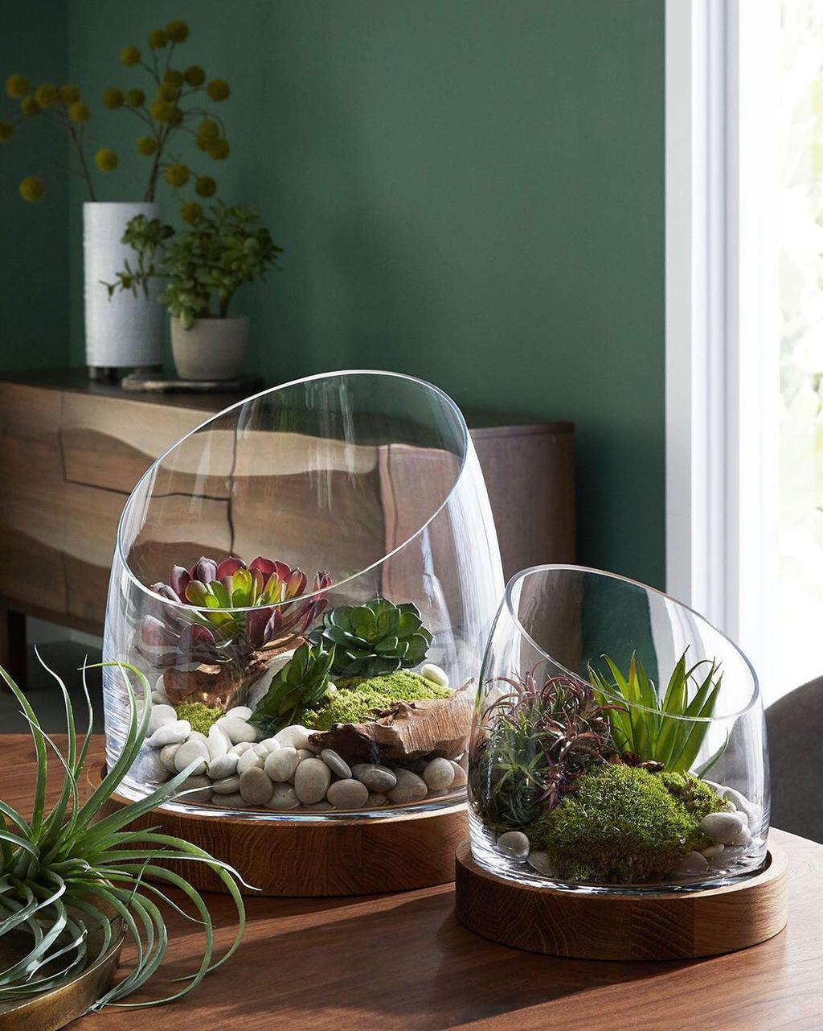

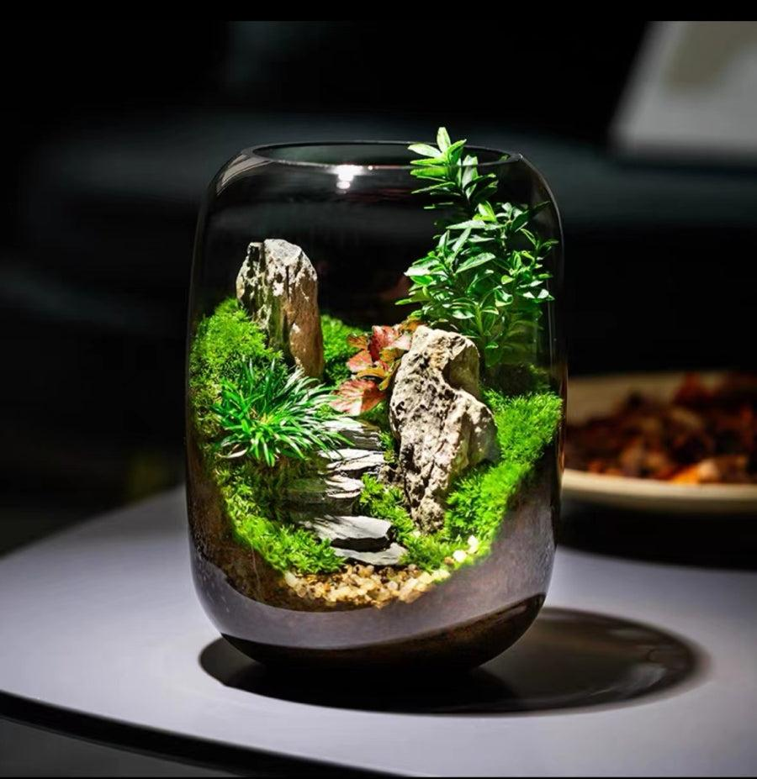
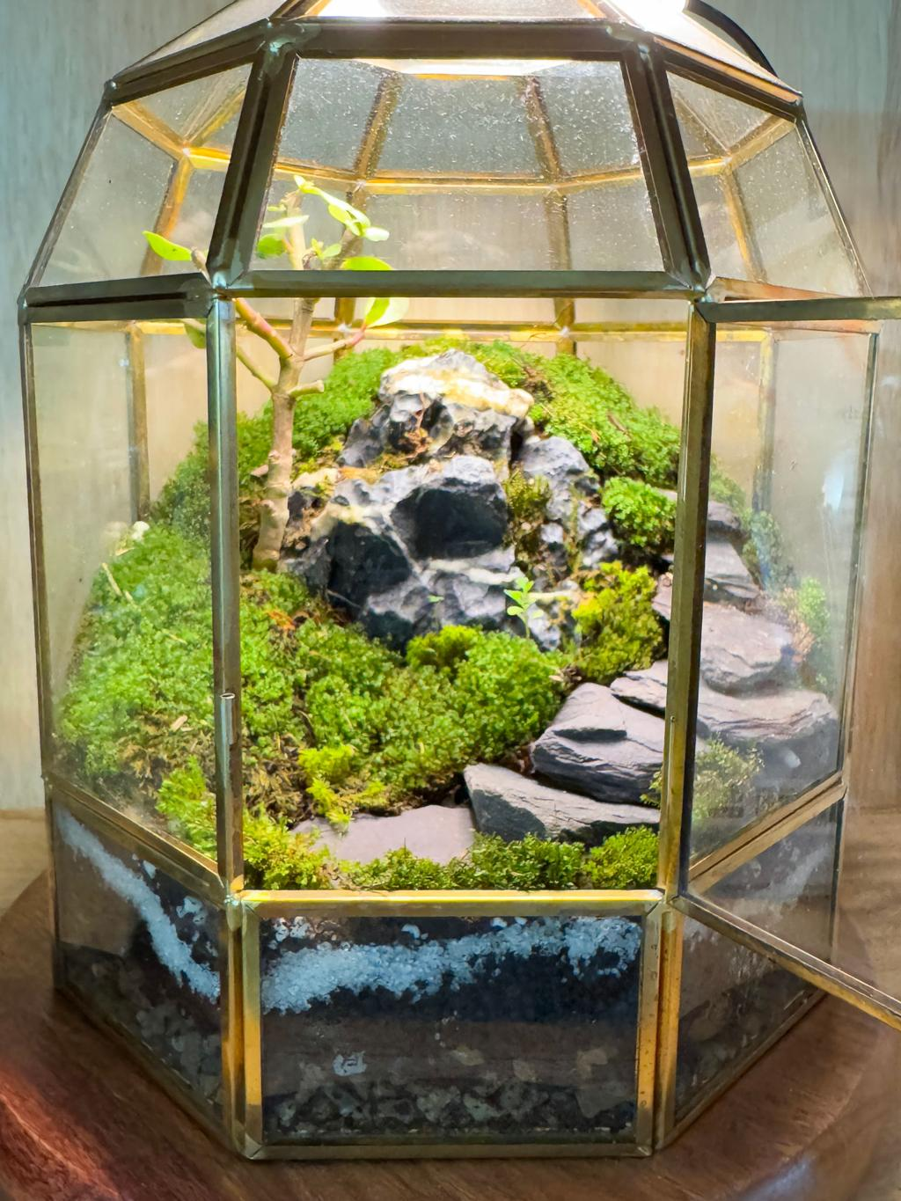
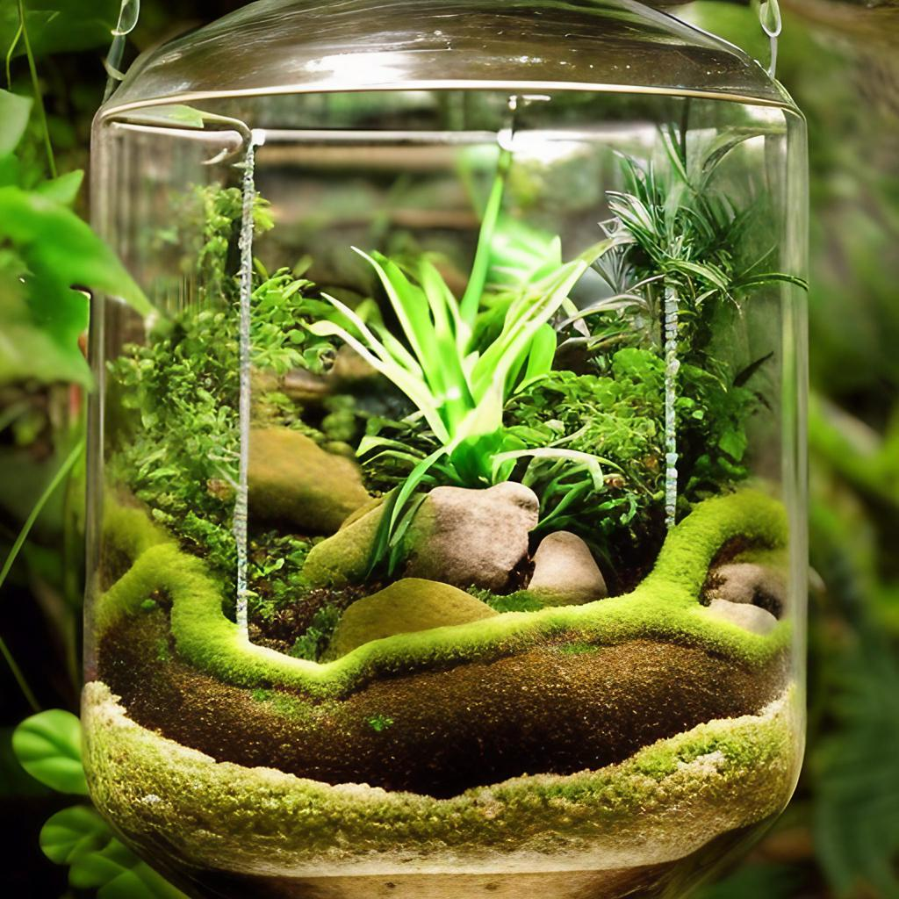

Recommendation for Regis & Savoy
move beyond a literal terrarium and develop a custom "Corporate Terrarium" visual language.
Imagine a bespoke terrarium where every element symbolizes part of your advisory philosophy:
- 🪨 Stone Layers → Business Structuring
- 🌱 Healthy Roots → Governance
- 💧 Water Balance → Risk Management
- 🪟 Glass Enclosure → Compliance & Protection
- 🌿 New Growth → Investment Readiness
- ✨ Light Entering the Glass → Strategic Guidance
- ⚖️ Perfect Balance → Sustainable Corporate Growth

